A language is called **Decidable** or **Recursive** if there is a Turing machine which accepts and halts on every input string **w**. Every decidable language is Turing-Acceptable.

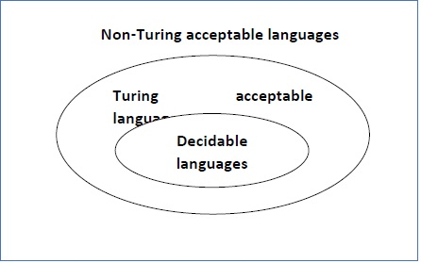

A decision problem **P** is decidable if the language **L** of all yes instances to **P** is decidable.

For a decidable language, for each input string, the TM halts either at the accept or the reject state as depicted in the following diagram −

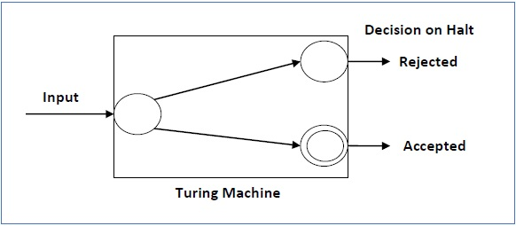

Example 1

Find out whether the following problem is decidable or not −

Is a number ‘m’ prime?

Solution

Prime numbers = {2, 3, 5, 7, 11, 13, …………..}

Divide the number **‘m’** by all the numbers between ‘2’ and ‘√m’ starting from ‘2’.

If any of these numbers produce a remainder zero, then it goes to the “Rejected state”, otherwise it goes to the “Accepted state”. So, here the answer could be made by ‘Yes’ or ‘No’.

**Hence, it is a decidable problem.**

Example 2

Given a regular language **L** and string **w**, how can we check if **w ∈ L**?

Solution

Take the DFA that accepts **L** and check if **w** is accepted

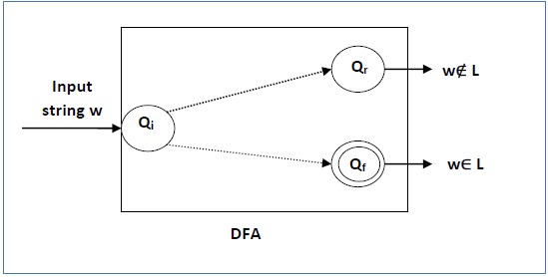

Some more decidable problems are −

* Does DFA accept the empty language?
* Is L1 ∩ L2 = ∅ for regular sets?

**Note** −

* If a language **L** is decidable, then its complement **L'** is also decidable
* If a language is decidable, then there is an enumerator for it.